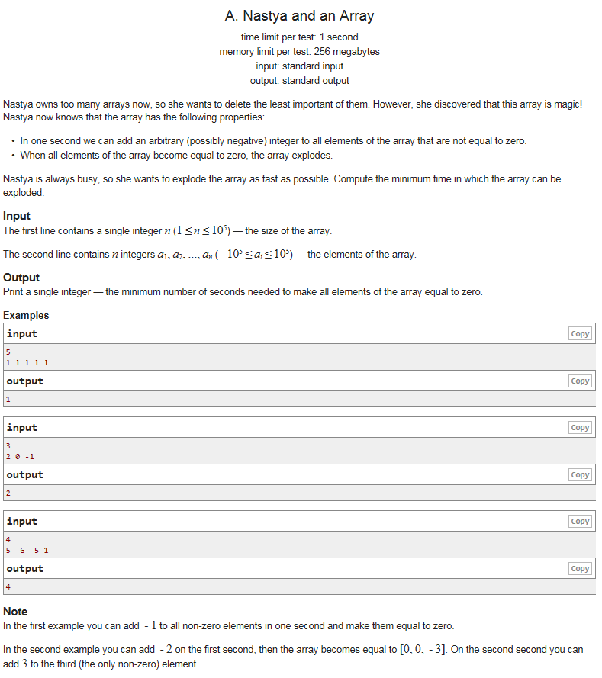

https://codeforces.com/problemset/problem/992/A